LabVIEW NXT Module Installation

1. Download LabVIEW Lego Module (LV2011NXT.exe) from

<http://joule.ni.com/nidu/cds/view/p/id/2637/lang/en>

1. Make sure your LabVIEW application is closed.
2. Unzip the file into a folder. Remember where it is.
3. Run setup.exe of installer and follow the instructions.

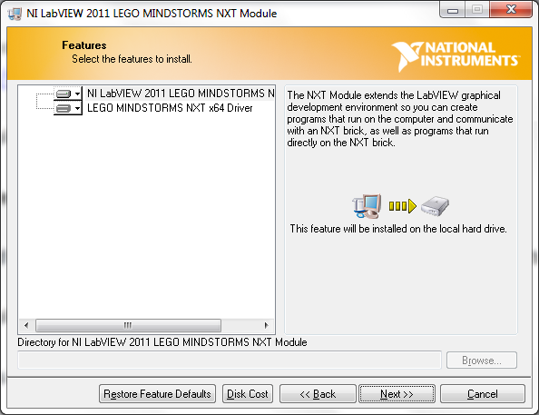

Press “Next”

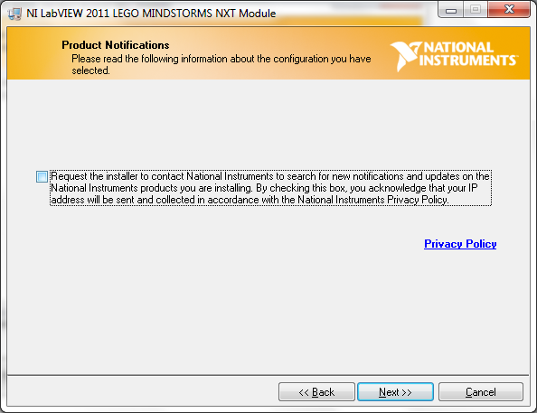

Uncheck box to “Request…”, press “Next”

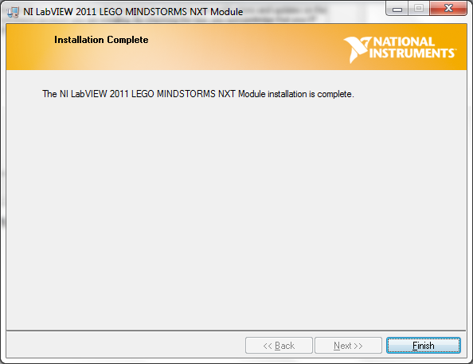

You should arrive at this screen shortly (under 5 minutes)

1. Verify that the NXT Module is installed by
2. Open up a blank VI
3. Go to the Block Diagram. Right click to bring up the functions palette
4. Expand the palette and ensure that you have the NXT Robotics palette

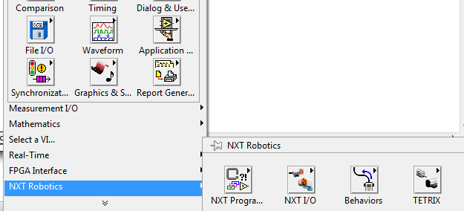

1. Download the drivers/toolkits for the sensor and motor that you will be using:

<http://www.mindsensors.com/index.php?module=documents&JAS_DocumentManager_op=viewDocument&JAS_Document_id=141>

You will find a .zip file and a .pdf file. Detailed instructions are in the pdf file and the toolkit is in the .zip file.